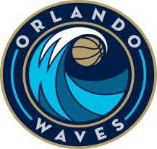 NEWS RELEASE 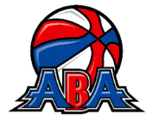
FOR IMMEDIATE RELEASE
DATE: July 25, 2016
CONTACT: Kevin Baldinger
PHONE: (407) 761- 3707
EMAIL: News@orlandowaves.com
http://orlandowaves.com/ https://twitter.com/OrlandoWaves
https://www.facebook.com/OrlandoWaves
Waves Heading Back to School

Orlando, Fl. – The Orlando Waves are happy to announce that they will be partnering with the City of Kissimmee and 360Entertainment International for Back 2 School Jam Saturday August 6th 2016, between 3pm and 6pm. The event will be held at the Chambers Park Community Center. 2380 N. Smith Street Kissimmee, Florida 34744.
This will be your chance to get ready for school, free book bag filled with school supplies, free haircuts with a live appearance by Destiny J, food bounce house and more.
Players and staff of the Waves will be on hand for photos, autographs, t-shirts and tickets to the team’s first game on November 5th 2016.

The original ABA did not have national television, national radio and today’s digital media. What it did have was the mystique of the ABA- featuring it’s red, white and blue ball, 3 point shots, wide open style of play including slam dunks (and the introduction of the first Slam Dunk Competition), and a remarkable group of players. The ABA produced some of the greatest players of the 20th century- Dr J, George Gervin, Spencer Haywood, Connie Hawkins, Dan Issel, Roger Brown, David Thompson, Mel Daniels, Moses Malone, Marvin Barnes and many others. In fact, 50% of the NBA All Star team in the first year of the merger were ABA players.
Today, the ABA has nearly 1000 players competing at the professional level, over 200 coaches and over 200 officials. It is made up of former NBA players, NCAA Division 1 and 2 players, McDonalds All Americans, international players, and is the platform for sending off many players to international teams.
The ABA will continue to grow as it continues to form valuable ties with basketball governing bodies, and grows its number of teams. Network coverage is set to broaden, as is the fan base and merchandising. Big things are in store for the ABA, and the red, white and blue ball is set to be around for a long time to come. For more information: www.americanbasketballassociation.org or www.abaliveaction.com.

