KALAMAZOO COBRAS PRESS RELEASE
Contact Amber Duncan  Telephone 269-910-0397  Cell 269-910-0397  Email Amber.kzoocobras@gmail.com  Website TBA | FOR IMMEDIATE RELEASE  June 8, 2016

Kalamazoo cobras vs. oshtemo fire department in “love for Logan” fundrasier game!!!

Kalamazoo Cobras will verse the Osthemo Fire Department scheduled for June 15th, 2016 in hopes to raise money for local Kalamazoo boy, Logan (3), fighting cancer like a champ!
Kalamazoo, MI, June 8, 2016– The Kalamazoo Cobras, members of the American Basketball Association announced today the fundraiser event scheduled against the Oshtemo Fire Department and the Professional Minor League Team. The event will take place at KVCC on, June 15th, on 9th Street in Kalamazoo, MI from 6-8pm.
“The Kalamazoo Cobras and the Oshtemo Fire Department are partnering up in this effort to create a great family event in hopes of raising money for Logan and his family. Logan is 3 years old, fighting cancer at the current time, gone through 4 surgeries, and his family needs our help. We are going to do just that. We would really love to see everyone from Kalamazoo there to support the Cobras at their first game on the court together, and to help Logan as much as we can!” –Amber Duncan, Owner.
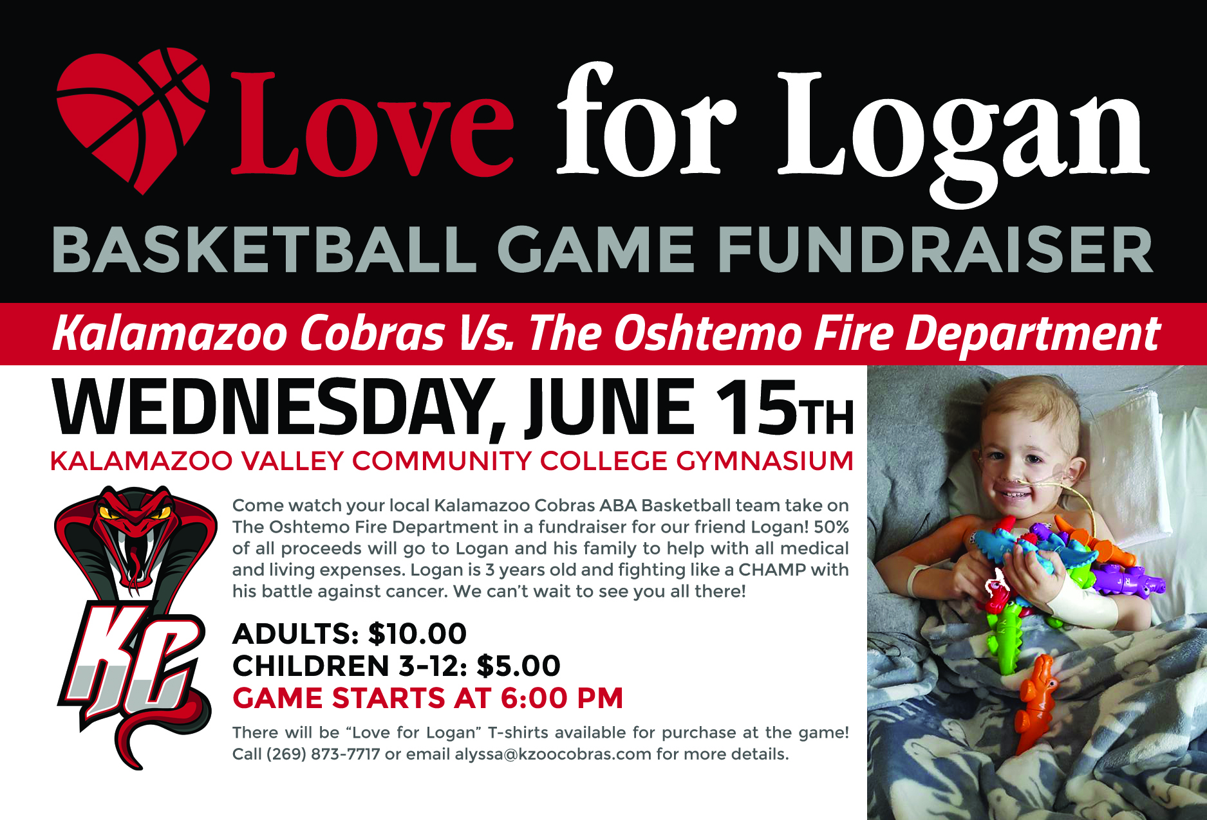
50% of all proceeds will go to Logan and his family to help pay for medical bills, and any living expenses they may need help with currently. There will be special “Team Logan” T-shirts for sale online on Facebook as well as at the event for people to wear. Anyone with questions can call 269-910-0397 if they are interested in making donations if they cannot make the game. The Cobras would like to thank the Community in advance for their support!

